M359 – AP Java Name: ________________________________

Unit 4 Lab Teacher: _________________ Per: ____

**Unit 4 Pig Latin**

**Program Requirements:**

For the unit 4 lab you will be writing a PigLatin class that can convert a phrase to Pig Latin. You will be given a tester program that has a series of String phrases and you will create a PigLatin object that will call its method toPigLatin and will return the translated phrase.

**If you search “Pig Latin” online, you will see there are many variations. For consistency, we will follow this limited set of rules shown below. You only need to worry about these three rules in your solution.**

1. words beginning with consonants -> consonant/consonant cluster goes to end, add "ay"

* cat -> atcay
* black -> ackblay

2. words beginning with vowels -> add "yay" to the end

* oval -> ovalyay
* apple -> appleyay

3. words beginning with y -> treat y as a consonant

* yellow -> ellowyay

**For your lab, you need to create a PigLatin.java class that follows these criteria:**

* Create several **static** methods to assist in the conversion of a phrase from normal English to Pig Latin
  + toPigLatin
    - This method will accept the *entire phrase* from the tester program that needs to be converted.
    - This method must call translateWordToPigLatin
  + translateWordToPigLatin
    - This method will translate a *single* word.
    - This method must call at least one helper method to assist in the process of translating the word.
  + Helper method of your choice, to be called in translateWordToPigLatin.   
    Suggestion - use a helper method to check if one of the rules is true or false
* The PigLatin class does not need to have any instance variables, do not create any.
* The PigLatin class does not need a constructor, do not create one.
* **The PigLatin class does not have a public static void main method. It is simply a collection of methods that are utilized in the Tester class!**

**Input: What you can assume**

* The input String will NOT be null. It will be a valid String.
* Each word will be separated by one space. We are not trying to trick you with multiple spaces between words.
* The Strings we will give you do not have punctuation, therefore you don’t need to worry about it
* The first letter of the phrase will be capitalized AND the first letter of the output phrase should be capitalized. You should NOT have a grammatically incorrect capital letter in the middle of a word in your Pig Latin answer.

Y**our code must run flawlessly with our tester program. This is what your output MUST look like. DO NOT TURN IN A LAB WITH CODE THAT DOESN’T RUN CORRECTLY.**

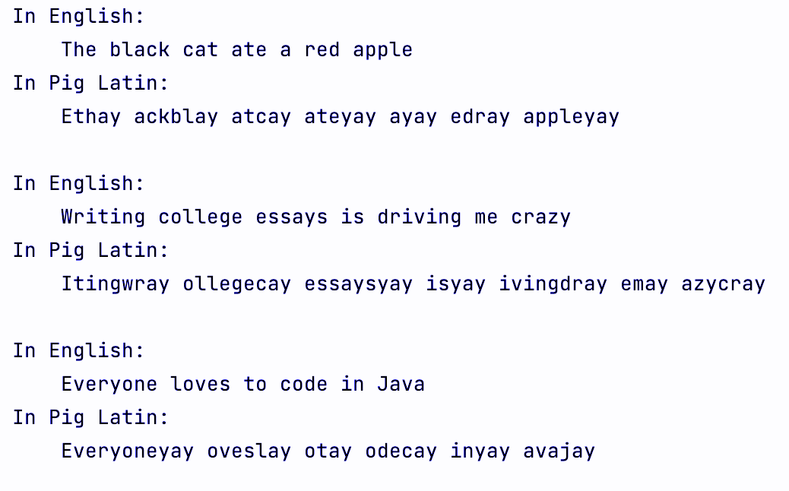

**To submit your code you will take a screencast of your computer showing the following:**

1. Please switch the mode of IntelliJ to light mode to make the video easier to view
   1. File -> Settings -> Appearance  
      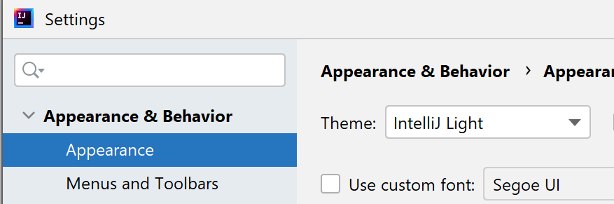
2. Slowly scroll through your code for PigLatin.java
3. Run your code to show the output is as it should be
4. Run the tester class to show your code passes all test scenarios and you have all green checks.
5. Upload the video or a link to the video in your google drive.
6. THERE IS NO NEED FOR AUDIO IN YOUR VIDEO